Solution Architecture

Parameter | Details
Date | 18 June 2026
Team ID
Project Name | Book A Doctor
Maximum Marks | 4 Marks

____________________________________________________

Solution Architecture:
Solution architecture is a complex process – with many sub-processes – that bridges the gap between business problems and technology solutions. Its goals are to:
- Find the best tech solution to solve existing business problems.
- Describe the structure, characteristics, behavior, and other aspects of the software to project stakeholders.
- Define features, development phases, and solution requirements.
- Provide specifications according to which the solution is defined, managed, and delivered.

Solution Architecture Diagram:

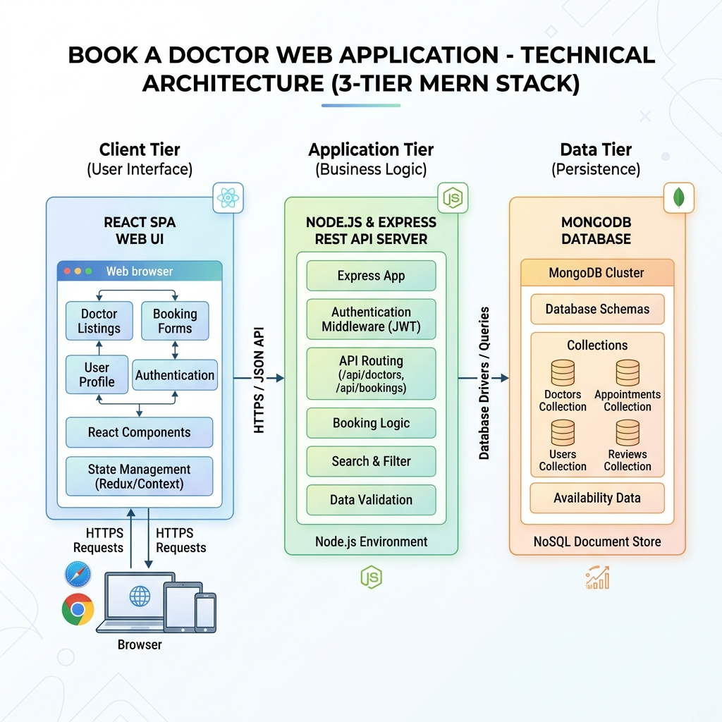
Architecture C4 Diagram

____________________________________________________

Components & Database Schema

User Model
Stores core authentication and identity fields:
{
name: { type: String, required: true },
email: { type: String, required: true, unique: true },
password: { type: String, required: true, select: false },
role: { type: String, enum: ['Patient', 'Doctor', 'Admin'], default: 'Patient' },
profilePic: { type: String, default: '' },
phoneNumber: { type: String, default: '' },
address: { type: String, default: '' },
notifications: [{ message: String, read: Boolean, createdAt: Date }],
timestamps: true
}

Doctor Model
Stores professional and scheduling details (references User):
{
user: { type: Schema.Types.ObjectId, ref: 'User', required: true },
specialization: { type: String, required: true },
experience: { type: Number, required: true },
fees: { type: Number, required: true },
about: { type: String, default: '' },
location: { type: String, required: true },
isApproved: { type: Boolean, default: false },
availability: [{
date: { type: String, required: true }, // YYYY-MM-DD
slots: { type: [String], required: true } // e.g. ["09:00 AM", "10:00 AM"]
}]
}

Appointment Model
Tracks scheduling bookings between a Patient and Doctor:
{
patient: { type: Schema.Types.ObjectId, ref: 'User', required: true },
doctor: { type: Schema.Types.ObjectId, ref: 'Doctor', required: true },
date: { type: String, required: true }, // YYYY-MM-DD
timeSlot: { type: String, required: true },
status: { type: String, enum: ['Pending', 'Approved', 'Rejected', 'Completed'], default: 'Pending' },
reason: { type: String, required: true },
notes: { type: String, default: '' }
}

Document Model
Stores patient medical record uploads:
{
patient: { type: Schema.Types.ObjectId, ref: 'User', required: true },
title: { type: String, required: true },
fileName: { type: String, required: true },
filePath: { type: String, required: true },
uploadedAt: { type: Date, default: Date.now }
}

____________________________________________________

Security Architecture
- Password Hashing: Done pre-save inside the User schema (bcryptjs).
- Access Control (Backend): Custom middleware functions:
- protect: Extracts the bearer token from headers, verifies using JWT secret, and attaches the user model to req.user.
- authorize(...roles): Checks if the user's role matches the allowed values for the API route.
- Route Guards (Frontend): Custom React ProtectedRoute component checking AuthContext to redirect unauthorized users to /login.

